PAC-POLY-Amsterdam-Burying Place-Cook-1784

**view of Afi-Too-Ca, a Burying Place, in the Island of Amsterdam**

33 cm x 22 cm copperplate engraving, 37.5 cm x 24 cm sheet size, modern hand colour, Alexander Hogg, London, 1784

We are pleased to offer this original 18th century fine art print depicting burial grounds observed by James Cook and his crew on the island of Nomuka (named Rotterdam Island by Abel Tasman) in the Haʻapai group of islands in the Kingdom of Tonga.  The image was drawn by John Webber (1751-1793) who accompanied Cook on his third and final voyage and also witnessed and recorded the famous scene of Cook's murder in Hawaii. David Samwell, Surgeon on the *Discovery*, described "Places set apart for burying the dead are raised with Gravel about a foot or two above the level off the Ground, on which stand two or three Houses which are constantly shut up but contain nothing in them…. Beside these there are others raised of Stones which are burying places of the Chiefs & are called Fyntocka."  Published in George William Anderson's *Voyages and Travels*, this example of the handsomely engraved print is accentuated with hand colour work of the very finest calibre and will make a fine presentation if matted and framed.  It will also serve as a reminder of an important charitable contribution - 100% of the proceeds from this auction will be donated to [Médecins Sans Frontières](http://www.doctorswithoutborders.org/home.cfm) (Doctors Without Borders) whose important humanitarian work sadly remains in high demand around the globe, so that along with acquiring this rare 18th century print a significant donation can be made to this worthwhile organisation.

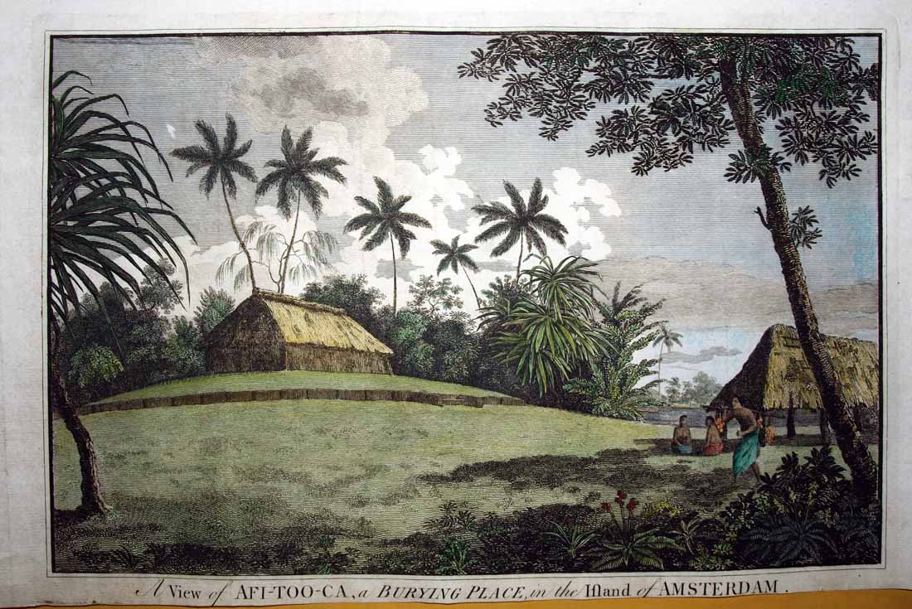

Note means of transporting yams:

